NEW STRAITS TIMES
SATURDAY OCT 24,2009
펴轉
-

ECONOMIC
REPORT

2009/2010

Sponsored by
A 빼BANK

REPORTS BY SHAHRIMAN JOHARI, RUPA DAMODARAN, ADELINE PAUL RAJ, CHONG POOI KOON, JEEVA ARULAMPALAM and AZLAN ABU BAKAR
Second wave of privatisation
Move to attract foreign investors and encourage joint venture projects

THE government plans to privat- ise selected government agencies and give customised incentives to attract fresh investments from the private sector.
Private investment, consumption to bolster growth
MALAYSIA’S economy is expec- ted to grow between 2 per cent and 3 per cent in 2010, supported by private investment and con- sumption.
Nominal per-capita income will also likely climb 2.5 per cent to RM24,661 in 2010 from RM24,055 last year.
With reduced government spending, the fiscal deficit is ex- pected to narrow to 5.6 per cent of gross domestic product (GDP) next year.
The deficit will be financed through domestic borrowing.
The balance of payments is ex- pected to remain favourable with the current account in surplus for 13 consecutive years. The cur- rent account surplus of 12.6 per cent of GDP will be contributed by the goods and travel accounts.
These developments augur well for the economy and provide a strong foundation for the trans- ition to a high-income economy, said the Economic Report 2009/2010 prepared by the Fin- ance Ministry.
This forms part of the govern- ment’s plan to develop a new economic model based on high income, which will be the focus in the 10th Malaysia Plan (10MP).
“Ample opportunities wil be created for the private sector by attracting foreign investors to take up equity positions in local companies and encouraging joint-venture projects,” said the Ministry of Finance’s Economic Report 2009/2010.
It did not say which agencies will be privatised, but this will be known as the second wave of privatisation.
The government will also im- prove the financial sector to fa- cilitate efficient intermediation. This means measures to enhance access, cut transaction costs and promote stockbroking and fund- raising activities.
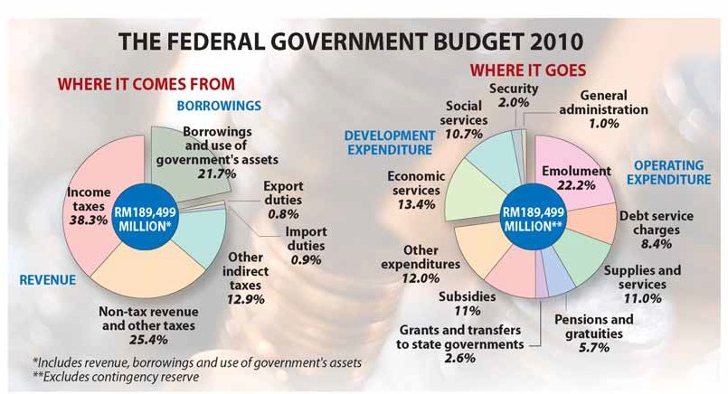There are also plans to keep motor vehicle insurance afford- able and money lending will be

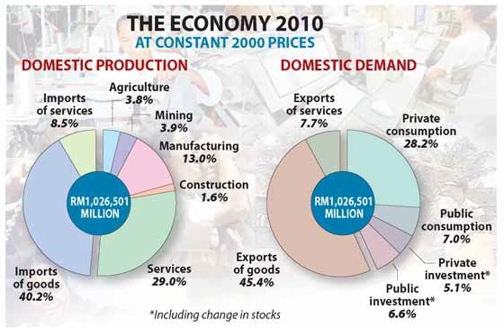monitored closely and regulated to protect consumers.
The government will also push for the development of green technology with a detailed blue- print, incentives and a supporting law.
The adoption of green techno- logy in public facilities will be encouraged, such as the design and use of eco-friendly mater- ials.
“Putrajaya and Cyberjaya will adopt the green concept to demonstrate its feasibility,” the report added.
There will be incentives to en- courage venture capitals, includ-

ing foreign ones, to fund innov- ation in green technology. A Na- tional Innovation Centre that will advise the government and have developmental functions will also be created.
The government will also ag- gressively promote niche growth areas like Islamic finance, the halal industry and tourism.
There will be incentives to de- velop creative content industries like animation.
Small and medium enterprises (SMEs) won’t be left out. There are incentives to help them mod- ernise and sustain their opera- tions. In addition, the numerous

grants and loan schemes will be rationalised to improve access and effectiveness.
Emphasis will be on improving the business acumen and ma- nagerial skills of entrepreneurs.
The agriculture sector is still an important focus for the govern- ment as it seeks to make it a major source of economic growth.
“...emphasis will be on aquaculture, swiftlet bird’s nest production, floriculture, deep sea fishing and sea weed production,” the report said.
The food supply chain infra- structure will also be improved to enhance the distribution system and exports while programmes to nurture agro-entrepreneurs will be strengthened.
In conclusion, the Budget 2010 will lay the groundwork for Malaysia’s plan to develop a new economic model and this will be continued in the 10MP.
The 10MP will be presented on June 10 next year and it will run from 2011 to 2015.
The Budget 2010 will focus on moving the country to a high- income economy by boosting the private sector as a growth driver and creating skilled workers.
In addition, research and de- velopment needs to be intensified while innovation and creativity will be promoted.
“...emphasis will be on creating a conducive environment for businesses and entrepreneurship to thrive in a more liberalised environment supported by mar- ket-driven policies,” the report said.
The government will also im- prove its finances, which is in deficit currently, to create fiscal flexibility.

Prudent policies to continue
Lower fuel subsidies and cut in discretionary spending among measures

ALTHOUGH the government had to spend more for 2009, it will con- tinue to remain prudent by re- ducing fuel subsidies, cutting dis- cretionary spending and imple- menting competitive bidding.
The government’s total expendit- ure has been forecast to rise by 8.9 per cent to RM213.7 billion for 2009 and this was mainly because of two stimulus packages, accord- ing to the Ministry of Finance’s Economic Report 2009/2010.

ity in the financial system and the government will fund the deficit entirely from domestic borrow- ings.
The government unveiled a first package of RM7 billion on Novem- ber 4 2008 and this was financed through savings from fuel sub- sidies. The focus was on projects that would have high multiplier effect and require low imports.
A dedicated Technical Committee and a Project Management Unit were also set up to manage and implement the package.
However, global conditions worsened and a second package, which was more comprehensive at

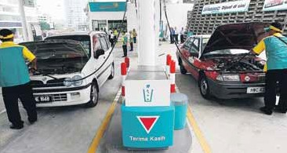
The government’s first stimulus package of RM7 billion on November 4 2008 was financed through savings from fuel subsidies

tinued to be healthy with capital levels strong enough to withstand any adverse impact. The bond and stock markets have developed as important sources of long-term funding.
The country even managed to maintain its lead in the issuance of Islamic bonds or sukuk, with more than 60 per cent of the global out- standing sukuk.
The government also introduced measures to strengthen the resi- lience of the financial sector. This includes new licences for conven- tional and Islamic banks and for family takaful and raising the for- eign equity limit in Islamic and

The federal government revenue
has been forecast to rise 1.4 per cent to RM162.1 billion.
“With the additional commit- ment arising from the stimulus packages, the fiscal deficit in 2009 is expected to widen to 7.4 per cent of GDP,” the report said. The deficit was 4.8 per cent in 2008.
However, there is enough liquid-
RM60 billion, was presented on March 10 2009. This involved a direct fiscal injection of RM10 bil- lion in 2009 and RM5 billion in 2010.
The focus was on easing the people’s burden, sustaining the flow of credit to the private sector, job creation and training, as well as capacity building for the future.
“As at end-September 2009,
RM8.2 billion was spent on both packages,” the report said.
On the other hand, the central bank used an accommodative mon- etary policy by lowering borrowing costs and the statutory reserve re- quirement (SRR). The SRR is the money that banks must keep at the central bank.
The Overnight Policy Rate, which
determines banks’ lending rates, was cut by 1.5 per cent between November 2008 and February 2009, to 2.0 per cent.
The SRR was also cut by 3 per cent to 1 per cent, to help reduce the cost of funds and sustain the flow of lending.
Malaysia’s banking sector con-
investment banks to 70 per cent from 49 per cent.
The higher limit also applies to insurance companies and takaful operators.
Malaysia also decided to scrap the Foreign Investment Committee, which oversaw the 30 per cent equity quota for Bumiputera in- vestors.

Strategies Under Budget 2009

NKRAs were identified namely crime, corruption, education, poverty, rural infrastructure and public transport.

- Ensuring the rakyat’s well-being
- Extending microcredit programmes
This comes under Amanah Ikhtiar Malaysia, Majlis Amanah Rakyat and Tabung Ekonomi Kumpulan Usahawan Nasional. Six banks and three development financial institutions also provide microfinance.

- Expanding the social safety net
Poverty alleviation was improved with eKasih, an integrated poverty information system. As at end-September 2009, 49,500 hardcore poor and 68,000 poor households were in the eKasih database.

- Improving rural infrastructure
In 2009, RM280 million was budgeted for water supply projects in rural areas. Another RM525.1 million was allocated for electricity supply projects in rural areas. Under the first stimulus package, RM1.4 billion is for rural roads, water supply, small businesses and poverty eradication projects.

- Encouraging corporate social responsibility RM100 million matching grant to repair houses of the hardcore poor. The expansion of the Promoting Intelligence, Nurturing talent and Advocating Responsibility (PINTAR) Programme to cover 480 schools by 2013, with priority to schools in Sabah and Sarawak.

- Improving public transport
The National Land Public Transport Commission will be set up to plan, integrate, regulate and improve the overall public transport system. The Light Rail Transit extension project is on track with construction starting in early 2010 and finishing in 2012.

- Enhancing food security
The launch of a Foof Security Policy. Five high- impact projects were given more money to increase food production.

- Expanding low-cost and affordable housing Syarikat Perumahan Negara Bhd was allocated RM200 million under first stimulus package to build 2,733 Rumah Mesra Rakyat. During the Ninth Malaysia Plan, the government will build 73,251 units through Program Perumahan Rakyat, which will be offered for rental or sale.

- Developing quality human capital
- Opportunities for post-graduate education RM50 million to fund tuition costs. As at September 15, 7,187 Masters and 452 PhD students benefited.

- Graduate Employability Management Scheme Graduates undergo two-and-a-half months soft skills training followed by six months on the job training with government-linked companies. It is expected to train 12,000 graduates over two years.

- Nurturing holistic development among children
RM150 million for the Childcare and Early Education Programme (PERMATA) to upgrade 478 centres covering 18,000 children nationwide.

- Creating jobs
Training programmes by Ministry of Human Resource, Bank Negara Malaysia and Securities Commission. As at end-September 2009, 49,000 participants are expected to be trained. Now, 19,380 participants are being trained.

- Strengthening the nation’s resilience
- Conducive environment for private investment Liberalisation of 27 services sub-sectors, the scrapping of the Foreign Investment Committee rules and the establishment of Ekuiti Nasional Bhd. The setting up of Danajamin Nasional Bhd to insure bond sales by companies.

- Loan guarantee schemes
The Working Capital Guarantee Scheme and Industry Restructuring Financing Guarantee Scheme to ensure credit flows to the private sector. Both schemes have a total limit of RM10 billion.

- Strengthening small and medium enterprises The establishment of the SME Financial Assistance Scheme, SME Assistance Scheme
and Micro Enterprise Fund. These funds totaled RM3.4 billion and as at end-August 2009, RM2.2 billion was approved for 12,938 companies.

- Accelerating Corridor development
Under the Ninth Malaysia Plan, RM7.5 billion was allocated to implement 191 projects in five regional corridors. In 2009, RM3.4 billion was allocated.

- Realising tourism potential
Under the second stimulus package, RM200 million was allocated to upgrade infrastructure at tourist spots, diversify tourism products, improve the homestay programme and to host more international conferences and exhibitions.

- National Key Result Areas (NKRAs)
NKRAs and Key Performance Indicators (KPIs) for ministers and head of departments have been set to assess performance of service delivery. Six
- Improving public service delivery Significant improvements by the Special Task Force to Facilitate Business. Among them,
reduced time for export clearance and property registration.

- Promoting auto sector
RM200 million Automotive Development Fund under the second stimulus package to consolidate Proton vendor scheme, promote
exports, build capacity and establish a soft loan scheme for vendors.

- Information and communication technology Industry
RM2.4 billion spending to improve telecommunication infrastructure in rural areas, RM400 million to speed up the High Speed Broadband Project. Commercial rollout of HSBB is expected in the first quarter of 2010.

- Promoting research, development and commercialisation
Three major funds established, namely the Sciencefund, Technofund and Innofund. The government ptovided RM2.7 billion for these programmes.

- Financing innovative firms
As at end-June 2009, RM4.9 billion have been approved to 937 applicants largely in ICT, biotechnology and life sciences.

- Strengthening airport infrastructure Construction of a new Low-Cost Carrier Terminal at the Kuala Lumpur International Airport and the upgrade of the Penang International Airport. The RM2 billion LCCT will start operations by September 2011. The Penang airport upgrade will cost RM250 million and due for completion by end-2011. Other international airports being upgraded are in Kuching and Kota Kinabalu.
Airports in Batu Berendam, Melaka, and Kota Bharu, Kelantan, are also being upgraded.

Inflation set for positive levels again

THE job market in the coun-
try is expected to continue improving this year, with the
Job market outlook improving this year

MALAYSIA’S inflation figure will probably return to pos- itive territory this year, rising to about 1 per cent from the current negative level.
Domestic inflation eased, with the Consumer Price In- dex (CPI) increasing at a slower pace of 1.3 per cent in the first eight months, due to the high base effect of fuel price adjustments in June last year, slower food price increases and moderate de- mand.
Inflation turned negative in June, with prices down 1.4 per cent from a year ago — the first time since August 1986 — and again in July and August, down 2.4 per cent.
Food and non-alcoholic beverages remained the biggest contributor to infla- tion during the period.
Prices in the transport group fell 9.3 per cent, res- ulting in a -1.3 per cent point change in the CPI following lower fuel retail prices com- pared with the previous year’s.
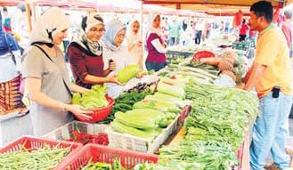According to the Economic Report 2009/2010, the neg- ative inflation is expected to be temporary.
Inflation has been subdued worldwide this year as crude oil and food commodity prices fell sharply on softer demand following the global downturn.
Crude oil prices declined
51.5 per cent to average US$55.7 (RM188.8) a barrel in the first eight months of the year, while prices of food commodities such as wheat, rice, soyabean, corn and palm oil dropped to between
4.3 per cent and 33.3 per cent.
The Producer Price Index (PPI) declined 9.5 per cent in the January-August period due to falling prices of food commodities and crude oil.
The major price declines involved animal and veget- able oils and fats, mineral fuels, lubricants and related materials.
The sharp drop in com- modity prices has seen the PPI falling since November last year, marking 10 con- secutive months of decline.
The PPI for local produc- tion declined 12.5 per cent, while that for imported com- ponents fell 3 per cent between January and Au- gust.
employment rate rising 0.1 per cent to 11.6 million jobs.
However, the increase will be smaller than last year’s
1.6 per cent.
Unemployment rose to 3.6 per cent in the second quarter of 2009; it was 3.3 per cent a year ago.
The labour force is envis- aged to increase 0.8 per cent to 12.1 million people this year compared with a 1.6 per cent rise to 12 million last year.
Labour force participation is expected to be sustained at
63.1 per cent. Male parti- cipation remains high at 79.5 per cent, while it is 46 per cent for female.
The 25-34 age group rep- resents the largest propor- tion, accounting for 31.4 per cent of the total workforce, followed by the 35-44 age group at 25.2 per cent.
The workforce with ter- tiary education is anticip- ated to increase 5.2 per cent to 2.6 million, constituting
21.9 per cent of the work- force.
The services sector is ex- pected to account for 52.6 per cent of total employ- ment, followed by manufac- turing, agriculture, con- struction and mining.
The government, under the second stimulus pack- age, initiated 163,000 train- ing and job placement op- portunities in both the public and private sectors.
Out of this, 100,000 were undertaken through collab- oration with the private sec- tor. As at September 28 this year, under both stimulus packages, 19,384 graduates, retrenched workers and

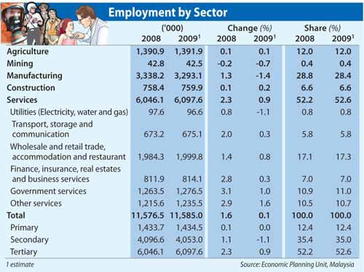the train-and-place pro- gramme.
Job vacancies reported through JobsMalaysia in- creased 25.9 per cent to 884,437 in the first eight months of 2009. In the pre- vious corresponding period, it was a 30.5 per cent in- crease to 702,326.
Vacancies in the manufac- turing sector rose 51.9 per cent to 328,711. This was followed by services, up 45 per cent to 328,194, and con- struction, up 4.9 per cent to 66,944.
Vacancies in the mining and agriculture sectors shrank 28.3 per cent and
17.9 per cent respectively.
Vacancies for professional jobs increased 28.6 per cent to 132,991, while those for elementary jobs were up
10.2 per cent, particularly in the manufacturing sector.
The share of professional jobs increased to 15 per cent, while elementary occupa-

Demand for graduate workers increased 70.5 per cent to 122,759, with ser- vices recording the highest.
The number of active job- seekers was 328,365 at end- August this year compared with 194,191 at end-Decem- ber last year.
To assist job-seekers, the government embarked on several initiatives, including organising job fairs and ac- tivating 80 operation centres to monitor retrenchments nationwide.
The number of retrenched workers was reduced to 641 in August compared with 8,383 — the highest re- trenchment level — a year ago.
The manufacturing sector saw 207 workers re- trenched, or 32.3 per cent. The manufacture of radio, television and communica- tions equipment and appar- atus sub-sector reported 159 retrenched workers.

ted to decline further with higher capacity utilisation in the manufacturing sector in the second half of 2009.
At end-January this year, the number of foreign work- ers fell to 1.9 million. It was
2.1 million at end-December 2008. This was due to higher retrenchments which re- duced the number of un- skilled foreign workers in the country.
About 34.6 per cent of the foreign workforce was em- ployed in manufacturing. This was followed by plant- ation (16.6 per cent) and construction (15.6 per cent).
The government encour- ages skilled expatriates to work in selected high-end in- dustries. At end-July this year, there were 33,601 ex- patriate workers, mainly from India (18.8 per cent) and China (8.6 per cent). The majority were in services (70.5 per cent) and manu-

Food is among the biggest contributors to inflation
youths were trained under
tions fell to 58.2 per cent.
Retrenchments are expec-
facturing (24 per cent).

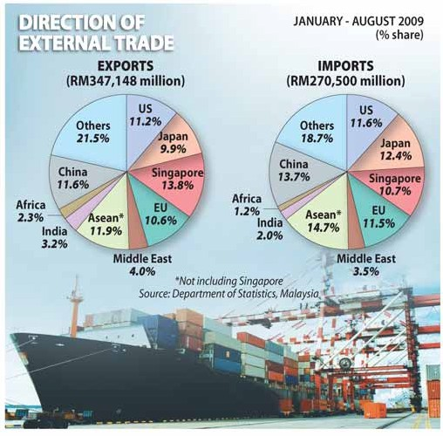Global crisis takes a toll on exports

MALAYSIA’S exports could contract 20 per cent to RM530.6 billion this year due to the impact of the glob- al economic crisis.
Manufactured goods, which account for 76.7 per cent of total exports, may see export fall 17.8 per cent to RM407 billion. Export of primary commodities is likely to drop 25.4 per cent to RM112 billion.
During the first eight months of the year, export earnings of the electrical and electronics (E&E) sector, which accounted for 55.8 per cent of total manufac- tured exports, fell 19.2 per cent as a result of substantial drop in electronic equipment and parts (-26.8per cent), machinery and electrical products (-22.5 per cent) as well as semiconductors (-7.3 per cent).
The trend is expected to bottom out, as indicated by higher book-to-bill ratio and gradual improvement in global chip sales.
Following these positive developments, export of E&E products are anticip- ated to pick up towards the end of the year.
While export of chemicals, chemical and plastic pro- ducts shrank during the

same period, export of medi- cinal and pharmaceutical products rebounded as de- mand for healthcare and medical device products rose.
Receipts of iron, steel and metal products declined 23.9 per cent along with a 43 per cent drop in export receipts of petroleum products.
Shipments of petroleum products were affected by in- tense competition from pet- rochemcial producers, par- ticularly in the Middle East.
The Economic Report 2009/2010 noted that export earnings of primary com- modities fell a significant
33.1 per cent to RM66.9 bil- lion in January-August, from RM100.1 billion a year ago, due to lower prices.
However, as export prices are expected to improve fur- ther in the second half of the
year, the earnings are en- visaged to show a smaller decline of 25.4 per cent to RM112. billion.
Export volumes of rubber are also expected to decline this year in tandem with lower global demand in the motor vehicle industry, with export receipts estimated to fall 53.3 per cent from RM8.1 billion last year.
Crude petroleum exports are expected to drop 39.9 per cent to RM25.9 billion this year, with an estimated average export price of RM1,702 a tonne.
Imports are projected to drop 18.6 per cent to RM424.5 billion from RM521.56 billion last year.
Intermediate goods are envisaged to decline 21.6 per cent to RM297.2 billion, while capital goods are ex- pected to contract 15 per cent to RM59.4 billion as in- vestment activities remain sluggish in the manufactur- ing sector.
Import of consumption goods may decline 7.1 per cent to RM30 billion due to lower domestic demand.
During the first eight months of the year, import of intermediate goods dropped
28.5 per cent, while import of parts and accessories as

well as industrial supplies declined 24.2 per cent and
27.5 per cent respectively.
Import of capital goods also contracted amid lower investment in the manufac- turing sector.
However, import of trans- port equipment for indus- trial use rose 10 per cent, driven by higher import of aircraft and ships as major

transportation companies took delivery in contractual orders.
The country’s balance of payments is expected to re- main favourable this year, with the current account posting a surplus for the 12th consecutive year.
The current account sur- plus is envisaged to narrow to RM91.8 billion due to

lower surplus in goods and higher deficit in services ac- count.
Overall balance is expec- ted to show a surplus, en- hancing the country’s strong international reserves.
In line with the expected sizeable trade surplus, Bank Negara Malaysia’s interna- tional reserves are envis- aged to strengthen further.

‘Stable world financial system vital’
Competition hits FDI inflow
FOREIGN direct investment (FDI) into the country declined 66.7 per cent in the first eight months of the year as the global economy slowed and competition from other emerging economies intensified.
During the January-August period, out of RM12.1 billion approved by the Malaysian Industrial De- velopment Authority (Mida), Japan ranked as the main contributor (RM6.5 billion), followed by Singa- pore (RM1.6 billion) and Taiwan (RM0.6 billion).
The Economic Report 2009/2010 said that do- mestic manufacturing investment approvals con- tracted to RM7 billion in the first eight months from RM11.9 billion in the same period last year.
Mida’s total approvals for manufacturing invest- ment declined 60.4 per cent to RM19.1 billion from RM48.4 billion in the period reviewed.
Selangor topped the number of projects approved (174), followed by Johor (101) and Penang (77).
About 70 per cent of the total projects approved was allocated in these three states.
However, in terms of value, Sarawak registered the highest level of investments at RM7.8 billion due to the availability of natural resources as well as efforts to promote balanced development in the country
q SEE PAGE 15, COL. 1

MALAYSIA will continue to speak out on the need for a more stable and resilient global financial system that can withstand future sys- temic shocks, the Economic Report 2009/2010 said.
In an increasingly integ-
In an increasingly integrated global economy, events that take place in one country can have far-reaching implications across the globe.
In addition, the large num- ber of low-skilled foreign workers in the country does not encourage employers to upgrade technology, pay better wages or initiate other measures to boost pro- ductivity, the report said.

rated global economy, events
and decisions taken in one country can have far-reach- ing systemic implications across the globe.
Although the country was on a much stronger footing after the Asian financial crisis, it was still affected by the current global recession which started from the dis- tress in the financial system in the West.
“Realising this, Malaysia continues to engage the in- ternational community through multilateral and re- gional forums and to reit- erate the need for a stable world financial system,” the report said.
Malaysia plans to focus more on Asia trade engage- ment as global consumption is expected to shift towards
this region. Local companies
are encouraged to expand to ride on this trend.
The US and Europe will stay as the main source of consumption demand, but Asean, China, India and the Middle East are gaining prominence.
The government has iden- tified Islamic finance, halal industry, resource-based in- dustries and tourism as areas in which Malaysia is competitive.
Malaysian firms also have an edge in oil and gas, plantation and construction sectors, which can be strengthened and promoted globally.
Workforce remains a key concern in the economy, which is dominated by low-
skilled workers, resulting in
slow growth in both pro- ductivity and salary.
Most of the workforce are only educated to Sijil Pela- jaran Malaysia level, while even the graduates are forced to take up low-skilled jobs.
This is partly contributed by the shortage of quality teachers. Despite improved compensation, teaching is still not a preferred career among Malaysians.
The high value-added in- dustries will need know- ledge workers.
However, secondary school students do not con- sider skills and vocational training as an option al- though career prospects are promising.
Private investment, the key source of growth in Malaysia before the Asian financial crisis, has fallen significantly. Private invest- ment was expanding 21.4 per cent on average between 1990 and 1997, but slowed to an average of 9.4 per cent between 1998 and 2008.
Several factors led to the low investment: market dis- tortions, the government’s significant involvement in economic activities, short- age of skilled workers, low investment in research and development, low productiv- ity, regulatory burden and high crime rates.
These issues must be ad- dressed if Malaysia is to be attractive to private invest- ment again.

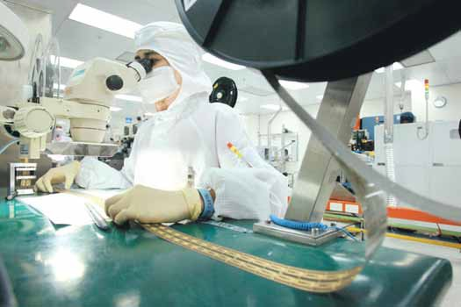Domestic demand will be main growth driver

DOMESTIC demand will be the main driver of growth for the Malaysian economy this year, due to higher public sector expenditure which is anticipated to grow by 12 per cent.
The 1.5 per cent expansion in domestic demand contrasts with the expected 2.4 per cent de- cline in private sector expendit- ure.
According to the Economic Re- port 2009/2010 by the Finance Ministry, private investment is ex- pected to contract by 20 per cent as a result of cautious business sen- timent.
The Business Expectations Sur- vey indicated that private sector capital outlay declined 6.6 per cent in the first half of the year.
The manufacturing sector con- tributed 36.1 per cent, the largest share of the total capital outlay,

followed by the services sector at
30.2 per cent.
Imports of capital and interme- diate goods declined 11.8 per cent and 28.5 per cent respectively for the first eight months of the year, while sales of commercial vehicles weakened by 3.4 per cent.
Total loans disbursed by the banking system to the non-house- hold sector contracted 5.7 per cent

Manufacturing sector contributes
36.1 per cent of the total private sector capital outlay

to RM352.2 billion from January till August.
The report said the lower in- vestment in the private sector is offset by higher public investment, which is anticipated to grow 24.8 per cent this year from 0.7 per cent in 2008. It is supported by the implementation of stimulus pack- ages.
Construction of low-cost houses as well as upgrading in- frastructure and basic amenities are expected to strengthen do-

mestic sources of growth.
Public sector investment is also backed by the capital investment of non-financial public enterprises such as Petronas, Tenaga Nasional and Telekom Malaysia.
Public consumption is expected to grow by 2.2 per cent, slower than the 10.9 per cent in 2008, based on the expenditure on supplies and services.
Private consumption is also expected to pick up in the second half of 2009, on low interest rates

and firm household disposable in- come.
It is expected to grow at a mod- erate pace of 1.6 per cent.
The 3 per cent cut in the Employees Provident Fund contri- bution is estimated to release up to RM5 billion into the economy. The positive trend in private consumption was reflected in total loans disbursed for consump- tion of credit and credit card spend-
ing.

Global recovery likely to firm up next year

THE global economic recovery, despite the massive injections of fiscal stimulus and accommod- ative monetary policy, is likely to be sluggish.
The growing signs of recovery in the global economy are ex- pected to firm up in 2010, with emerging and developing coun- tries, particularly Asia, leading the rebound.
The Economic Report said the investment and consumption are still low while unemployment re- mains high.
With banks continuing to rebuild their balance sheets, credit flows will be constrained in advanced economies. This could impact capital flows to emerging and developing eco- nomies.
It said further efforts were needed to strengthen and restore confidence in the financial sys- tem especially in the advanced economies.
Private investment and con- sumption as well as assistance for the poor and the vulnerable groups need to be enhanced to restore growth.
The report said the interna- tional financial architecture must be reformed to prevent the re- currence of a crisis and to ensure sustained economic and financial stability.
The crisis appears to be abat- ing, due to the fiscal stimulus totalling about US$5 trillion (RM17 trillion) together with the monetary measures.
In the developed economies,
the crisis prompted a substantial injection of capital into financial markets by their central banks.
They also provided extensive assurances to depositors and creditors of banks and some non- bank financial institutions through blanket guarantees on deposits and guarantees on bank debt issues, to restore investor confidence.
To forestall further writedowns and credit losses, the US and several European countries pur- sued bank intervention strategies that included arranged takeovers of the weaker entities by stronger partners, closures and national- isation.
In the case of emerging and developing economies which
have initially appeared immune to the global financial crisis, they adopted measures to ease credit conditions by providing emer- gency liquidity support to the do- mestic banking system.
As the crisis deteriorated and affected the real economy, fiscal stimulus measures became policy priorities.
The financial crisis, the most severe since the Great Depres- sion, triggered by the bankruptcy of one of the biggest global in- vestment banks in the US in September 2008, led to a sharp contraction of the global eco- nomy.
From a financial crisis, it de- veloped into an economic crisis as output fell and unemployment rose.
The financial system can be traced to the loose monetary policy in the major advanced eco- nomies after the dot-com crash of 2001.
As a result, aggregate demand exceeded domestic output in the US, raising the current account deficit.
Emerging economies had ac- cumulated current account sur- pluses after the Asian financial crisis, with investments in US Treasury bills.
The Federal Reserve Board tightened monetary policy as in- flation edged up, resulting in rising mortgage payments which led to defaults on subprime loans and large losses for banks and financial institutions.

Agriculture sector contracts on lower oil palm output

THE local agriculture sector con- tracted 2 per cent during the first half of 2009 due to lower pro- duction of oil palm, the largest con- tributor to the sector.
Output of the non- commodity sub-sector including lifestock, fishing and other agriculture expanded strongly with the implementation of various programmes.
The programmes focused on commercialising and modernising farming practices to increase pro- ductivity and income of farmers as well as food supply.
For the year, value-added of the agriculture sector is estimated to decline 2.3 per cent following lower output of oil palm and rubber.
In spite of lower output, the share of agriculture sector to gross do- mestic product (GDP) is estimated to increase to 7.6 per cent.
Value-added of the oil palm sub- sector declined 3.3 per cent in the first six months of 2009 due to the decrease in crude palm oil (CPO) production.
The was attributed to lower yields and unfavourable weather, coupled with increasing replanting activities.
In the first nine months, CPO production fell 3.7 per cent to 12.5 million tonnes. For the whole year, it is expected to decline 4.1 per cent to 17 million tonnes.
Fresh fruit bunches (FFB) yields declined to 13.6 tonnes per hectare in the first nine months on account

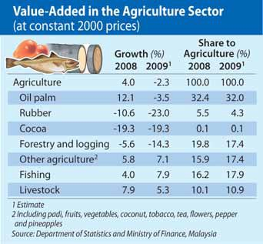of biological tree stress, heavy rain- fall in early part of the year and replanting activity.
Meanwhile, the oil extraction rate increased to 20.5 per cent due to improvement in milling effi- ciency and zero tolerance of unripe fruit.
Oil palm cultivated areas expan- ded 3.9 per cent to 4.58 million ha due to increase in new planted areas, mainly in Sarawak.
The clearing of new land is ex- pected to increase oil palm cul- tivated areas by 3.6 per cent to 4.65 million ha in 2009.
During the first nine months of 2009, CPO prices (local delivered)

improved to average RM2,234 per tonne due to tight supply and fall- ing stock.
Price of CPO is expected to be firm in the second half due to sus- tained seasonal demand and con- cerns of lower production arising from El Nino effect.
CPO price is expected to average RM2,300 per tonne in 2009.
Meanwhile, value-added of the rubber sub-sector registered sharp contraction of 31.5 per cent due to decline in rubber production.
During the first seven months, rubber production reduced by 29.7 per cent to 466,501 tonnes, fol- lowing weak demand.
Declining planted areas also con- tributed to the lower output.
For the year, production of rub- ber is expected to contract 21.7 per cent to 840,000 tonnes. However, average yield per ha should in- crease to 1.5 tonnes due to the wider use of Low Intensity Tapping System (LITS) and higher yield rub- ber clones.
The latest high-yield rubber clone, RRIM 3001, is expected to boost latex production up to 3,000 kg per ha per year.
Malaysia remains the third largest producer of natural rubber, after Thailand and Indonesia, con- tributing 10.4 per cent of total world supply.
The government aims to main- tain at least one million ha of cul- tivated areas with annual replant- ing of 20,000 ha to sustain the growth of rubber industry. As such, almost 8,800 ha were replanted in the first six months of 2009.
The average price of Standard Malaysian Rubber 20 declined to RM5.71 per kg in the first nine months of the year due to lower global demand. Rubber price is set to trade higher in the second half of 2009 supported by recovering global demand.
It is expected to average RM5.70 per kg for the whole year.
Value-added of the fishing sub- sector recorded sturdy growth of
10.4 per cent, attributed to the increase in marine fish landings and aquaculture produce.
Marine fish landings expanded
4.2 per cent in the first seven
months of the year, following vari- ous incentives given by the gov- ernment.
For the year, the fishing sub- sector is estimated to grow strongly by 7.9 per cent.
Value-added of the livestock sub- sector grew 5.2 per cent-driven by higher production of poultry and cattle.
The production of poultry is ex- pected to expand 5.5 per cent, be- nefiting from the establishment of poultry permanent food produc- tion parks in Johor, Kelantan, Pa- hang and Terengganu.
Value-added of cattle and goat farming increased 12.5 per cent and 38.8 per cent.
This sub-sector is estimated to grow 5.3 per cent in 2009.
Value-added of other agriculture sub-sector comprising padi, pine- apple, tobacco, coconut, veget- ables, fruits, flowers, tea and pep- per posted strong growth of 8.8 per cent.
This was due to an increase in acreage of fruits and vegetable cul- tivation as well as promotion of Good Agricultural Practices (GAP). In 2009, self-sufficiency level (SSL) of fruits is expected to reach
64.6 per cent with the implement- ation of Program Dusun Komersial and increase utilisation of idle land for agriculture purposes.
Padi production is envisaged to turn around 4.6 per cent in 2009 due to greater technology usage, improvement in irrigation and drainage system as well as im- plementation of GAP.

Declining trend in manufacturing bottoming out

THE country’s manufacturing sec- tor saw a fall of 14.8 per cent in output in the first eight months of this year, due to sharp deterior- ation in export- and domestic-ori- ented industries.
Sales value of manufactured products declined 24.7 per cent to RM299.8 billion. However, there are signs that the declining trend is bottoming out.
On a month-on-month basis, pro- duction and sales of manufacturing products have been improving not- ably since March this year.
The domestic-oriented indus- tries declined 9.8 per cent as a result of lower output of chemicals and chemical products, construc- tion-related materials and food products.
Export-oriented industries de- clined 19 per cent, with significant
second half of the year due to vari- ous initiatives to stimulate world growth.
Signs of recovery in the domestic- oriented industries have began to emerge, reflected by improved pro- duction in the construction-related and resource-based industries as well as transport equipment sub- sector.
The capacity utilisation rate im- proved to 81.7 per cent in the third quarter of 2009.
With these positive develop- ments, value-added of the man- ufacturing sector is set to decline at a slower pace of 12.1 per cent in 2009.
In the domestic-oriented indus- tries, production of chemicals and chemical products declined 7.7 per cent due to lower production of industrial gases and basic indus-

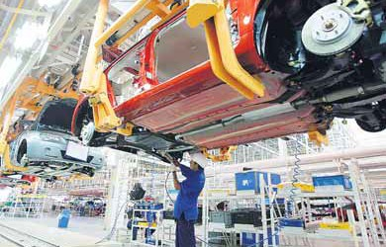

Production of passenger cars above 1,SOOcc, especially the luxury car segment, increased 6.9 per cent.
0.2 per cent due to lower output of refined palm oil, processed fish products and other food products. However, production of sweetened condensed milk in- creased 35.8 per cent due to lower cost of dairy raw materials while production of whole rice and broken rice grew 49.6 per cent and
8.9 per cent respectively.
Output of plastic products con- tracted 9.1 per cent following lower demand for components from the E&E and transportation sub-sec- tors. This was reflected in lower production of plastic injection moulded components, plastic bags and films.
Output of transport equipment fell 13.5 per cent during the first eight months of 2009 following lower production of commercial vehicles, motorcycles and scooters

contraction in electrical and elec- tronics, machinery and equipment and wood products following weak external demand.
Better prospect for export-ori- ented industries is expected in the
trial chemicals.
Production of fertilisers also con- tracted 19.2 per cent on account of weak demand from the oil palm plantation as commodity prices have yet to recover fully.
Output of construction-related materials contracted 11.2 per cent, following lower production of basic iron, steel, glass and glass products.
However, new orders for some
construction-related materials in- creased such as hydraulic cement and structural metal products, spurred by accelerating public works.
Production of food products grew
as well as passenger cars below 1,500 cc.
But output of passenger cars above 1,500cc, especially the lux- ury car segment, increased 6.9 per cent.

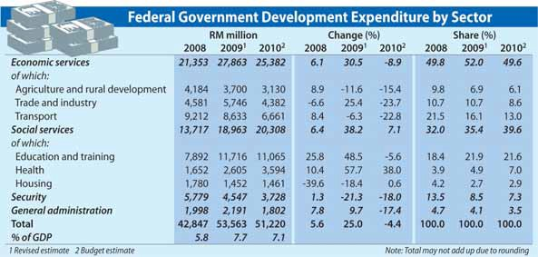Public sector to expand 12pc

AS THE external sector collapsed and the business community re- mained cautious and risk averse, government intervention became crucial to sustain demand by sup- porting domestic economic activity.
The two stimulus packages an- nounced in November 2008 and March this year, were designed to
State govts’ account surplus
to decline
THE financial position of state governments is projected to re- cord a lower current account surplus of RM7.2 billion this year, from RM8.9 billion in 2008, due to higher operating expenditure and a decline in revenue.
With growth in development expenditure expected to out- pace revenue, the consolidated financial position will register a small deficit of RM367 million in 2009, the first since 2003.
The overall deficit will be fin- anced largely by federal gov- ernment grants and loans as

protect jobs, provide skills training
and re-training, facilitate private sector activity as well as ease the burden of vulnerable groups.
As a result of the expansionary fiscal stance adopted by the gov- ernment, the fiscal deficit is expected to widen further from 4.8 per cent in 2008 to 7.4 per cent this year.
The Economic Report 2009/2010 noted that the public sector is ex- pected to expand 12 per cent, con- tributing 2.9 percentage points to gross domestic product (GDP) growth (2008: 6.3 per cent; 1.5 per- centage points).
“As the key driver of economic growth in 2009, the public sector’s
share to the GDP will remain high at
27.9 per cent compared to last year’s 24.2 per cent,” it said.
The report noted that develop- ments in the external environment will continue to impact the fiscal position of the federal government despite steady revenue collection.
“Weak private investment, slug- gish export performance and high- er expenditure incurred due to the implementation of the stimulus packages are expected to weaken the financial position of the federal government,” it said.
Total expenditure for 2009 is es- timated to stand at RM213.7 billion while revenue collection at
RM162.1 billion.
As for revenue, the government’s income this year is projected to be firm despite slower growth pro- spects for the domestic economy.
“Total revenue collection is ex- pected to register a marginal growth of 1.4 per cent to RM162.1 billion or 23.4 per cent of GDP,” the report said. However, tax revenue is expected to decline 5.7 per cent to RM106.5 billion, contributing 65.7 per cent to total revenue.
This is on account of the con- traction in direct and indirect taxes, reflecting slower private investment and consumption activity as well as lower profitability of businesses.
In contrast, returns on invest-
ment as well as proceeds from se- curitisation are expected to boost non-tax revenue by 18.5 per cent to RM55.6 billion from RM46.9 billion previously.
The oil and gas industry remains the largest contributor to tax rev- enue, followed by wholesale and retail, manufacturing and financial intermediaries.
The federal government’s ex- penditure is expected to rise 8.9 per cent to RM213.7 billion against 2008. Of this, RM160.2 billion, or
74.9 per cent, is for operating ex- penditure and the rest for devel- opment purposes.
well as the use of accumulated financial assets of state gov- ernments.
Total revenue is projected to drop 4.8 per cent to RM16.3 billion, from RM17.2 billion last year, mainly due to contraction in indirect taxes and lower re- turns on investment.
Royalties from petroleum and forestry, investment income, land premiums and other land- related taxes are the major con- tributors to the state govern- ments’ revenue accounting for
53.3 per cent.
Other sources of revenue in- clude fees from licences and permits, rents as well as re-

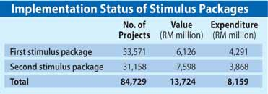Stimulus packages worth RM67b to stimulate economy
ceipts from services.
Grants and reimbursements

THE global financial crisis took a turn for the worse towards the second half of 2008, prompting the government to announce two stim- ulus packages worth a combined RM67 billion to help stimulate the slowing economy.
Under the first stimulus package of RM7 billion, a sum of RM6.9 billion was disbursed to various ministries and agencies.
“A total of 53,571 projects worth RM6.1 billion have been awarded and at end-September, RM4.3 bil- lion had been spent,” said the Eco- nomic Report 2009/2010.
By the end of this year, all projects are expected to be fully implemented, benefitting more than 50,000 con- tractors ranging from classes F to A.

Meanwhile, under the second stimulus package of RM60 billion, disbursements to ministries and re- lated agencies as at end of Septem- ber amounted to RM14.5 billion and contracts worth RM7.6 billion have been awarded for 31,158 projects.
Expenditure to date is RM3.9 billion with 10,710

projects completed.
“By the end of 2010, all pro- grammes and projects under the package are expected to be com- pleted,” the report said.
Three guarantee schemes amounting to RM25 billion were also introduced to restore investor confidence and ensure sustained
credit flows to support private sec- tor activity.
They are the Working Capital Guarantee Scheme, Industry Re- structuring Financing Guarantee Scheme and Financial Guarantee Institution.
The positive impact of fiscal measures complemented by mon- etary easing was seen especially in the construction sector, which re- gistered positive growth of 1.1 per cent in the first quarter of 2009.
This was largely attributed to the implementation of maintenance works on schools, hospitals and government quarters as well as small rural infrastructure projects.
q SEE PAGE 10, COL. 1
from the federal government will amount to RM2 billion or
12.2 per cent of state revenue. In line with efforts to con-
tinuously improve public amen- ities and service quality, the state governments are expected to incur higher operating and development expenditure.
Operating expenditure is ex- pected to increase 11.4 per cent to RM9.1 billion, while devel- opment expenditure will go up
12.1 per cent to RM8.2 billion.
Development expenditure will be utilised for agriculture and rural development, drain- age and irrigation, water supply projects, housing, public amen- ities and infrastructure.

Higher spending, consumption to spur mild rebound in 2010
Scheme to transform GLCs
starting to

THE domestic economy, spurred by higher public sector spending and private consumption is expected to experience a mild recovery in 2010.
The Economic Report 2009/2010 said the recovery will be accel- erated by revitalising private in- vestment and domestic consump- tion activity, while ensuring all public sector projects and pro- grammes under the stimulus pack- ages and Ninth Malaysia Plan are completed on schedule.
It said with the modest recovery next year and as the fiscal con- solidation resumes, the federal government’s revenue is expected to decline 8.4 per cent to RM148.4 billion.
In line with prudent financial management, the government will align expenditures to available re- sources to ensure fiscal stability and macro-economic stability.
The report said the government’s budget for 2010 will be RM189.5 billion, a decline of 11.3 per cent

over 2009.
“Private sector activity is expec- ted to pick up following signs of recovery, enabling the government to consolidate its fiscal position for greater policy flexibility in times of crisis,” it said.
With lower revenues, coupled with prudent spending, the finan- cial position of the government is expected to improve, registering a smaller deficit of 5.6 per cent of gross domestic product.
Financing of the deficit will be
primarily from non-inflationary domestic sources.
Operating expenditure is expec- ted to decline markedly by 13.7 per cent to RM138.3 billion due to lower expenditure on major com- ponents such as subsidies (RM20.8 billion) as well as grants to stat- utory bodies (RM11.2 billion).
While fiscal discipline is pursued with cutbacks in discretionary ex- penditure, the government will en- sure productivity and quality of service is not affected.
Fuel subsidies, however, will be allocated a higher sum of RM10 billion, or an increase of 10.7 per cent, in anticipation of rising crude oil prices.
As for development expenditure, a sum of RM51.2 billion will be allocated in 2010, or 4.4 per cent lower than this year, as spending is expected to taper off with the com- pletion of projects under the Ninth Malaysia Plan.
“This is not expected to dampen economic activity as the rebound in
the global economy, reinforced by accommodative fiscal and monet- ary measures will provide mo- mentum for continued growth,” the report said.
Education and training, health, housing and welfare services are the priority under the social ser- vices sector.
Education and training sub-sec- tor is given the largest allocation of RM11.1 billion to meet the demand for skilled and knowledgeable workforce.
The report said quality and ef- ficiency of government spending will be improved and subsidies will be reviewed to remain lean and well targeted.
Through prudent financial man- agement and implementation of pragmatic policies, the fiscal po- sition of the government will re- main healthy.
“As economic recovery takes hold and becomes more en- trenched, fiscal consolidation will be pursued,” it said.

show results
THE programme to transform gov- ernment-linked companies (GLCs) into high performing entities are starting to show results after it was first implemented in 2004.
The Economic Report 2009/2010 said tangible results are emerging, backed by the sup- port and commitment from the government.
The Putrajaya Committee on GLC High Performance (PCG), which was established to provide guidance and monitor the pro- gress of the transformation pro- gramme, maintained the mo- mentum through a set of key per- formance indicators strategically aligned with the broader goals of the GLC Transformation (GLCT) programme.
It said changes in GLC senior management and board compos- ition were key transformation ini- tiatives that led to significant fin- ancial and operational improve- ments.

Mining sector
to contract at slower pace
The transformation programme started with GLCs embarking on cost-cutting and balance sheets re- structuring measures, which were necessary to lay the foundations for healthy growth.
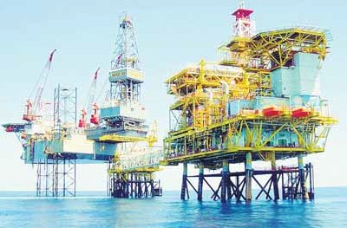The immediate impact was a drop in aggregate earnings of G-20 in 2005.
G-20 is a selection of companies controlled by government-linked investment companies namely Khazanah Nasional Bhd, Permod- alan Nasional Bhd, Employees

VALUE-ADDED in the mining sec-
tor contracted 3.9 per cent in the first half of 2009, due to lower output of crude oil and natural gas.
The sector was affected by weak demand from major importers and lower prices.
With the anticipated recovery in
unplanned shutdowns of oil fields,
especially in Peninsular Malaysia. For the year, crude oil produc-
tion is estimated to contract 4.8 per cent to 663,000 bpd.
Petroliam Nasional Bhd (Petro- nas) discovered one new oil field (PAUS) in offshore Sarawak and one new gas field (Sepat Barat) in

Seven new oil fields and nine gas fields have begun production, increasing the total number of producing fields in Malaysia to 104
Provident Fund, Lembaga Tabung Haji and Lembaga Tabung An- gkatan Tentera.
However, it was followed by sev- eral years of solid growth, as the initial restructuring efforts started to produce results.
Several other initiatives include operational turnaround pro-

the global economy and rising ex-
ports of liquefied natural gas (LNG) to China, the sector is expected to improve in the second half of the year.
However, it will contract at a slower pace of 2.9 per cent for the full year.
Production of crude oil (including condensates) declined 5 per cent to 667,862 barrels per day (bpd) dur- ing the first eight months of 2009, following external demand and prices.
This was further compounded by
offshore Peninsular Malaysia this
year.
Seven new oil fields and nine gas fields have begun production, in- creasing the total number of pro- ducing fields in Malaysia to 104, of which 68 are oil and the remaining are gas.
Currently, Malaysia’s crude oil reserves replacement ratio (RRR) stands at 1.1 times.
As at January 1 2009, crude oil reserves were at 5.52 billion bar- rels and are expected to last for 22 years based on the current pro-
duction level.
For the year, production of nat- ural gas is expected to increase 2.1 per cent to 2,084,200 mmscf, arising from higher demand in the second half of the year and in- creasing shipments of LNG to China.
In addition, the current expan- sion of MLNG DUA facilities in Bin- tulu is expected to increase pro- duction capacity by 1.2 million tonnes.
Gas reserves stood at 87.9 trillion cu ft as at January 1 2009, suf-
ficient to last for 36 years.
The price of West Texas Inter- mediate, which plummeted to a five-year low of US$31.41 (RM106) per barrel in December 2008, has since recovered to average US$69.44 (RM235) per barrel in September 2009.
In tandem with this, Tapis Blend traded at an average price of US$70.94 (RM240) per barrel in September 2009, compared with US$42.65 (RM144) per barrel in December 2008.
grammes (Malaysia Airlines and Bank Islam), strategic reposition- ing through mergers (Sime Darby Bhd) and de-mergers (TM and Axi- ata).
The report said although ag- gregate earnings fell 24 per cent in 2008 due to the global economic slowdown, it was still 53 per cent higher than in 2004.
“Majority of G-20s are now re- porting positive economic profits and have made significant im- provements with total shareholder returns outperforming the FTSE Bursa Malaysia KLCI by 2.4 per

Stimulus plans’ full impact to be felt in Q3, Q4
cent,” it said.
Market capitalisation is also 60 per cent or RM96 billion higher since the launch of the GLC trans-

q From Page 9 Boosted by higher spending and improving private consumption,
the economy contracted at a slower pace of 3.9 per cent in the second quarter.
The services and agriculture sec- tors rebounded to register growth of 1.6 per cent and 0.3 per cent respectively, while the construc- tion sector strengthened further to
2.8 per cent.
Full impact of the two stimulus packages is expected to be more significant in the third and fourth quarters of this year, spilling over into 2010.
“With improving domestic de-
mand reinforced by a pick-up in global economic activity, the eco- nomy is expected to register a slower contraction of 3 per cent in 2009 and mild recovery in 2010,” the report said.
formation programme.
Moving forward, the GLCT pro- gramme will focus on intensifying efforts to institutionalise best practices across all GLCs and en- sure the objectives of the GLCT are achieved in 2015.

Capital market funds surge 64pc to RM110b
Building sector gets boost from stimulus plans

GROSS funds raised in the capital market in the January-July period this year in- creased by 63.7 per cent to RM109.7 bil- lion.
This was much stronger than the 3.1 per cent growth seen in the same period a year ago.
After redemptions, net funds raised ex- panded more than twofold to RM68.4 bil- lion. The public sector accounted for RM45 billion of this.
The issuance of government securities grew by 109.3 per cent to RM66.3 billion, compared with a 6.1 per cent growth last year, in line with the government’s ex- pansionary fiscal policy.
Funds raised included the RM5 billion Sukuk Simpanan Rakyat 2009, a three- year savings instrument with an annual return of 5 per cent.
New private debt securities (PDS) is- suance by the private sector rose by 1.5 per cent to RM31.8 billion, slightly slower than the 1.7 per cent growth last year.
Islamic bonds remained a key segment of the PDS market, with Islamic medium- term notes and sukuk comprising 53 per cent of total bonds issued as at end-July.
Funds raised in the equity market ex- panded nearly threefold to RM11.7 billion, compared with a 54.7 per cent growth last year.
Fund-raising by the private sector picked up in the second quarter in tandem with improving business sentiment.
This year, a number of major changes were introduced in the equity market.
On July 6, the new FTSE Bursa Malaysia KLCI comprising the 30 largest companies by market capitalisation replaced the 100- component KLCI as the benchmark in- dex.
Other changes include the merging of the Main Board and Second Board into a single unified board known as the Main Market. The Mesdaq Market was trans-

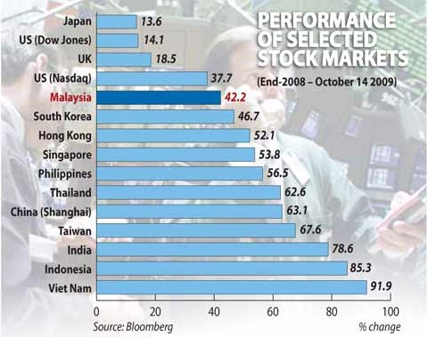formed into an alternative market known as the ACE Market.
Total market transactions on Bursa Malaysia surged 63.7 per cent to 150.4 billion units in the first seven months this year compared with 91.9 billion units in the same period last year.
Improved market sentiment contributed to higher retail participation at 36 per cent in the January-July period compared with 24 per cent for the whole of 2008.
Market velocity was sustained at 37 per cent while market volatility was lower at 15 per cent compared with 21.6 per cent in the same seven-month period last year.
Fund-raising through initial public of- ferings was lacklustre in the January-July period, with four domestic companies raising RM216.8 million.
Eight companies took their shares private, resulting in a RM2.7 billion re- duction in total market capitalisation.
Funds raised from rights issues involved a larger amount of RM11.3 billion.
The total number of listed companies stood at 957 as at end-July, among the highest in the region.
The derivatives market registered growth of 5.3 per cent in trading to 3.8 million contracts in the January-July peri-

od compared with 3.6 million contracts in the same period last year.
Turnover was dominated by crude palm oil futures, accounting for 61.4 per cent of the total, followed by FBM KLCI futures with 36.3 per cent, while trading in other derivative instruments remained insigni- ficant.
Meanwhile, the unit trust industry saw 26 new funds launched in the first seven months, bringing the total to 541 funds compared with 532 as at the end of last year.
The total net asset value of the industry rose 37.5 per cent to RM179.4 billion and accounted for 20.3 per cent of Bursa Malaysia’s market capitalisation as at end- July.
Market capitalisation of real estate in- vestment trusts, or REITs, rose 14.1 per cent to RM4.6 billion as at end-June com- pared with RM4 billion at the end of last year.
As for the venture capital (VC) industry, there were 108 companies as at end-June. Total funds committed for VC investment grew 38 per cent to RM4.6 billion as at end-2008 compared with RM3.3 billion a year earlier, with government agencies remaining the biggest source of VC funds.
THE construction sector expanded by 2 per cent in the first half of 2009, slower than the 4.5 per cent pace of expansion in the same period last year.
The growth was attributed to strong perform- ance of residential, non-residential and special trade works sub-sectors.
This was driven by implementation of various projects under the stimulus packages, which among others, include building low- and medium- cost houses as well as upgrading, repairing and maintenance of public buildings and rural roads.
As at September 30 2009, a total of 84,729 projects worth RM13.7 billion were implemented.
Apart from increased government spending, im- proved consumer sentiment and the stabilising job market conditions as well as strong performance of FBM KLCI are expected to augur well for the sector.
For full year 2009, the sector is expected to grow
3.5 per cent from last year, the third successive year of positive growth.
Meanwhile, the civil engineering sub-sector fell
2.5 per cent following a weak performance in the first half of this year.
This is in tandem with the completion of most projects at the tail end of the Ninth Malaysia Plan such as the Duta-Ulu Kelang Expressway and the Kajang-Seremban Expressway.
However, ongoing civil engineering projects and implementation of two stimulus packages to up- grade rural infrastructure are expected to support the sub-sector.
Ongoing projects include the East Coast Ex- pressway Phase 2 Jabur-Kuala Terengganu, up- grading Penang Bridge, electrified double track projects between Sentul-Batu Caves and Seremban-Gemas as well as Program Penyeng- garaan Infrastruktur Awam and Projek Infrastruk- tur Asas.
The residential sub-sector grew 3.6 per cent during the first half of 2009. The implementation of Home Ownership for the People project to provide affordable low- and medium-cost houses helped to offset sluggish private housing activities.
A total of RM200 million has been allocated in the first stimulus package to build 2,733 units of Rumah Mesra Rakyat for the low- and medium- income group, of which 1,200 units have been built.
Despite the sluggish private housing activity, the high-end property segment performed better, with newly-launched condominiums and apartments registering higher take-up rate of 32 per cent to 1,178 units during the first half of 2009.
q SEE PAGE 12, COL. 1

Services industry bounces back

DURING the first half of 2009, value-added of the services sector grew slightly by 0.7 per cent, due to the decline in trade and consump- tion-related activities.
On a quarter-on-quarter basis, the sector saw a sharp turnaround of 4.4 per cent in the second quarter of 2009.
With the economy showing signs of recovery, the sector may register growth of 2.1 per cent and account for 57.9 per cent of GDP in 2009.
The intermediate and final ser- vices groups are expected to ex- pand 2 per cent respectively.
Growth in the intermediate ser- vices group will be led by the com- munication, finance and insurance sub-sectors. The final services group will be supported by higher activity in accommodation, res- taurant, wholesale and retail trade sub-sectors.
The communication sub-sector is expected to grow 5.7 per cent in 2009, driven by strong expansion in the telecommunications in- dustry.
During the first half of the year, the sub-sector posted favourable growth of 5.3 per cent, attributed to higher usage of cellular, broad- band and third generation ser- vices.
As at end-June 2009, the cellular phone subscriber base grew 13.8 per cent to 28.5 million with a

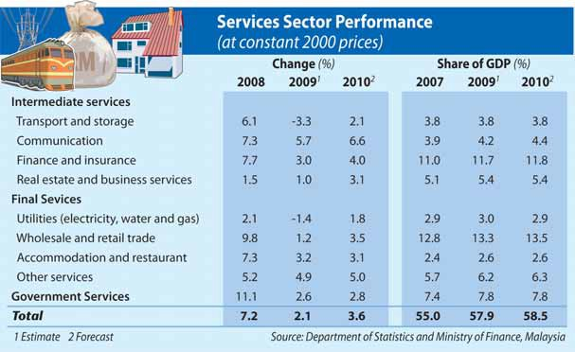penetration rate of 100.8 per cent. The cellular phone subscriber base is anticipated to grow further by 11.4 per cent to 30.2 million with a penetration rate of 105.6 per cent
by year-end.
Broadband subscriber base grew
53.9 per cent to 2.1 million with a household penetration rate of 24.8 per cent, driven by increasing de- mand for Internet access and wider network coverage.
As for postal service, total rev- enue collected by Pos Malaysia Bhd contracted 2 per cent during the first half of 2009 due to reduced

postal and courier activities.
The finance and insurance sub- sector is expected to expand 3 per cent in 2009 supported by steady financing activities for consumer credit and business investment.
As at end-July 2009, total loans outstanding of the banking system grew 8.4 per cent to RM752.5 bil- lion with loans to small- and me- dium-sized enterprises and house- holds comprising 15.9 per cent and
54.7 per cent respectively.
Financing in the Islamic banking sector grew 12.4 per cent to RM169.2 billion and accounted for

20.2 per cent of total banking sys- tem loans as at end July 2009.
The real estate and business ser- vices sub-sector is expected to grow 1 per cent in 2009 due to higher stock broking, shared ser- vices and outsourcing activities as well as information technology re- lated services.
During the first half of 2009, value-added of the wholesale and retail trade sub-sector contracted marginally by 0.6 per cent due to lower private consumption follow- ing weaker consumer sentiment and business confidence.
However, the wholesale and re- tail trade sub-sector is expected to grow 1.2 per cent in 2009 due to the establishment of new retail com- plexes and expansion of major hy- permarkets and superstores.
The accommodation and res- taurant sub-sector grew 2.5 per cent in the first half of 2009, sup- ported by continuous promotional activities, particularly by fast food outlets and higher tourist arrivals. The overall performance of the sub-sector should increase 3.2 per cent in 2009 with expenditure on accommodation remaining the largest component of total tourist receipts, followed by shopping, and
food and beverages.
Value-added of the transport and storage sub-sector declined signi- ficantly by 5.2 per cent in the first six-months of 2009 due to slower economic performance, more so in travel and trade-related activities. Overall, this sub-sector is expec- ted to contract 3.3 per cent in
2009.
Value-added of the utilities sub- sector is expected to decline 1.4 per cent in 2009 due to lower demand in electricity. During the first half of 2009, electricity generation de- creased 4.9 per cent while water supply grew 1.8 per cent to 13,436 million litres per day.
The other services sub-sector is expected to increase 4.9 per cent, supported by higher activity in private education and healthcare services.
The government services sub- sector is estimated to expand 2.6 per cent in 2009 attributed to high- er expenditure on emoluments.

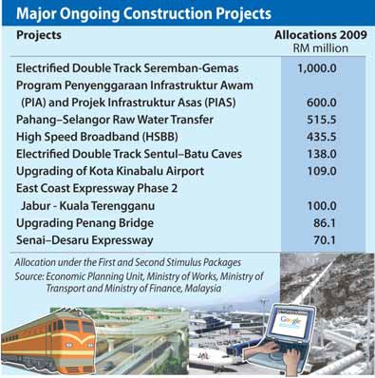Occupancy rate of retail space remains high in 2nd quarter 2009

q FROM PAGE 11

With developers being cautious, new launches of residential units were lower by half at 16,069 units compared with the first half of 2008.
During the January-June peri- od, 55,682 units were completed, resulting in an increase of total stock by 3.2 per cent to 4.26 mil- lion units. Given the lower supply and increased sales of high-end properties, the property overhang improved to 21,467 units as at end-June 2009.
To further stimulate demand, low-cost house buyers were given full stamp duty exemption, while medium-cost property pur- chasers were given a 50 per cent stamp duty exemption for houses priced up to RM250,000.
An additional RM100 million was injected into the Housing Credit Guaranteed Scheme to as-
sist those without fixed income to
own a house.
House buyers were also given tax relief on interest paid on hous- ing loans up to RM10,000 a year for three years. As for civil ser- vants, the tenure for housing loan facility was extended from 25 to 30 years.
The low interest rate and at- tractive packages offered by de- velopers helped to renew buying interest, especially in high-end properties and preferred loca- tions.
The Foreign Investment Com- mittee (FIC) guidelines for prop- erty transactions were also sub- stantially relaxed to stimulate for- eign investment in the property market.
The non-residential sub-sector expanded 6.3 per cent driven by ongoing construction activities of commercial properties, especially purpose-built office and hotels.
Occupancy rate of purpose-built
office in the second quarter of 2009 increased to 85.7 per cent following improved business con- fidence in the second quarter of 2009.
During the first half of 2009, 19 new shopping complexes offering 224,175 sq m of new retail space were completed. Consequently, the stock of retail space expanded
2.7 per cent to 9.98 million sq m as at end-June 2009.
Despite slower economic activ- ity, occupancy rate of retail space remained high at 81.7 per cent in the second quarter of 2009, re- flecting sustained consumer and business sentiments in the retail trade.
Construction activity in the leisure property expanded fur- ther, supported by the govern- ment’s continuous effort in pro- moting tourism-related indus- tries.

This helped to boost the con- struction of 77 hotels with 20,921 rooms.
In the first half of 2009, eight new hotels were completed com-

prising 1,208 rooms. There were two completions each in Sarawak and Sabah, and one each in Put- rajaya, Perak, Penang, and Ter- engganu.

Monetary policy to remain supportive of growth
Danajamin gets requests to guarantee bonds worth RM1.7b
DANAJAMIN Nasional Bhd, the country’s first financial guaran- tee institution with an “AAA” rating, has received seven ap- plications to guarantee RM1.7 billion of bonds as at end- September.
The applications are from the oil and gas, property and con- struction as well as the financial services sector.
Danajamin was set up by the government in May to facilitate capital-raising by local compan- ies that find it tough to access funds under current challenging conditions.
The entity, with a capital base of RM1 billion, can underwrite policies of up to RM15 billion.
It will guarantee corporate bonds and sukuk with at least a “BBB” rating.
With the guarantee, the bond rating will be enhanced to AAA, thus enabling companies to have access to lower-cost funds.
Danajamin is regulated and supervised by Bank Negara Malaysia.
MONETARY policy next year will continue to remain supportive of growth, says Bank Negara Malaysia.
The Malaysian economy is ex- pected to grow by between 2 per cent and 3 per cent in 2010.
The central bank’s key interest rate, the Overnight Policy Rate (OPR), was cut by 75 basis points (bps) in January this year and a further 50 bps in February to 2 per cent. This marked a total

reduction of 150 bps, following an earlier cut of 25 bps in Novem- ber last year.
The OPR has since been left unchanged, amid signs of im- provement in the economy and further moderation in inflation.
This policy stance will continue to be assessed against the risks and outlook for growth and in- flation, according to the Econom- ic Report 2009/2010.
The Statutory Reserve Re- quirement (SRR), meanwhile, was cut by 300 bps to 1 per cent between December and March to reduce the cost of intermediation

Malaysia’s policy stance will continue to be assessed against the risks and outlook for growth and inflation
through the banking system and capital market stood at RM404.9 billion in the first seven months this year, almost similar to the RM400.5 billion in the same peri- od last year.
Meanwhile, the ringgit depre- ciated against major and regional currencies in the first half of this year, on account of export con- traction and capital outflows.
It depreciated 1.7 per cent against the US dollar to RM3.5225 as at end-June and eased between 0.1 per cent and
8.4 per cent against regional cur-

for banking institutions. Monetary aggregates had ex-
panded at a slower pace in the first seven months this year. Nar- row money, or M1, grew by 6 per cent as at end-July compared with 8.3 per cent as at end- December on account of higher placement of demand deposits by
business enterprises.
Broad money, or M3, increased by 5.3 per cent compared with
11.9 per cent due mainly to high- er bank lending to the private sector, supported by lower in- terest rates and ample liquidity.
With the cuts in OPR, the av- erage base lending rate of com-
mercial banks fell to 5.89 per cent
in February and 5.53 per cent in March, and has stayed at that rate since.
Increased competition among local banks led to the average lending rate declining to a his- toric low of 4.96 per cent in July. Gross private sector financing
rencies.
From July to October 14, however, the ringgit appreciated by 4.4 per cent against the US dollar and 9 per cent against the pound sterling, but depreciated
3.1 per cent against the yen and 1 per cent against the euro.

Insurance sector remains sound despite lower premiums

THE domestic insurance industry remained sound and resilient in the first seven months of this year, thanks to a strong asset base, in- creased premium growth, sus- tained profitability and solvency levels.
Combined premium income grew
1.9 per cent to RM15.8 billion, which was slower compared with
6.3 per cent growth in the same period last year.
New business premiums of the
life insurance sector fell 5.4 per cent to RM4 billion on lower sales of investment-linked products, which have remained lacklustre since late 2008.
Sales of investment-linked products fell 53.7 per cent to RM784.1 million.
Net premium income rose 0.9 per cent to RM10.8 billion. Market pen- etration improved to 41.1 per cent as at end June compared with 39.9 per cent a year ago.
In the general insurance sector, gross direct premiums grew 5.5 per cent to RM7.1 billion, driven by an increase in fire, motor and mis- cellaneous insurance business.
Motor insurance is the largest business in the general insurance sector, accounting for 42.8 per cent of total gross premiums.
The insurance industry’s asset base grew 12.4 per cent to RM141.3 billion. Liquid assets amounted to RM41.7 billion, suf-
ficient to cover claims and benefits of RM9.8 billion as at end-July.
The capital adequacy ratio of the industry remained strong at 214.8 per cent as at end-June.
The profitability of the life in- surance business improved in the January-July period, with excess of income over outgo (spending) at RM6 billion compared with RM5.2 billion in the same period last year.
The general insurance business
recorded an underwriting loss of RM180.5 million, which was an improvement over the loss of RM281 million last year.
The improvement was due to higher earned premium income and a reduction in management expenses.
There were 40 insurance com- panies in Malaysia as at end-July compared with 56 as at the end of 1999, following an industry con- solidation.

Banks remain sound and resilient despite downturn

THE country’s banking system has remained resilient and sound with strong capitalisation and sustained asset quality, despite the economic downturn.
As at end-July 2009, banks’ risk- weighted capital ratio and core capital ratio improved to 14.3 per cent and 12.7 per cent, respect- ively. These compared with 12.6 per cent and 10.6 per cent as at the end of last year.
The banks’ pre-tax profits, however, declined by a quarter to RM8.4 billion in the first seven months of this year compared with the same period last year.
This was attributed to a one-off provisioning adjustment by “a large banking institution”, the Eco- nomic Report 2009/2010 stated.
Overall, however, core income sources from financing activities, cross-selling of bancassurance and wealth management services, as well as treasury activities, re- mained stable.
The banking system’s net non- performing loans (NPL) fell by 5.1 per cent to RM15.1 billion as at end-July, from RM15.9 billion at

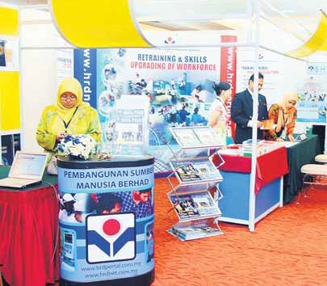
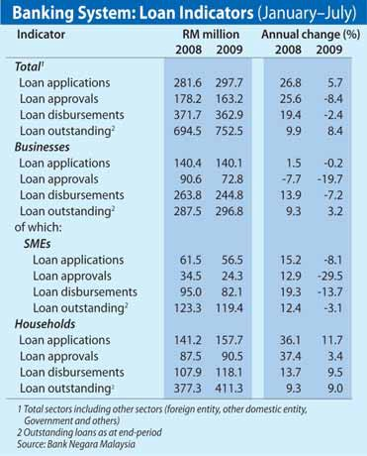The five special SME funds, including the RM200 million Micro Enterprise Fund set up in November last year, were well utilised at 88.6 per cent as at end-July.

the end of last year, on better re- coveries.
The three-month net NPL ratio further improved to 2.1 per cent at end-July after holding steady at 2.2 per cent since December last year. The banking system’s loan per- formance moderated in the Janu- ary-July period, mainly due to a
decline in business loans.
Total loan approvals and dis- bursements fell by 8.4 per cent and
2.4 per cent respectively from the same period last year.
However, total loan applications
increased by 5.7 per cent, sup-
ported by a rebound in business loan applications since May.
Total loans outstanding grew by
8.4 per cent to RM752.5 billion as at end-July.
Business loan applications, ap- provals and disbursements fell by
0.2 per cent, 19.7 per cent and 7.2 per cent, respectively, in the first seven months this year.
The bulk of loans disbursed were mainly for working capital.
Meanwhile, loan applications, approvals and disbursement to
small- and medium-sized enter-
prises (SMEs) fell 8.1 per cent, 29.5 per cent and 13.7 per cent, re- spectively.
The five special SME funds ad- ministrered by the central bank, including the RM200 million Micro Enterprise Fund set up in Novem- ber last year, were well utilised at
88.6 per cent as at end-July.
Micro financing offered by nine financial institutions grew strongly, with total loans outstand- ing having increased 44.8 per cent to RM587.5 million as at end-Au-

gust, benefitting 54,900 clients. Household loan applications, ap-
provals and disbursements in- creased 11.7 per cent, 3.4 per cent and 9.5 per cent in the first seven months, supported by low interest rates as well as improving labour market conditions and consumer sentiment.

Loans outstanding of develop- ment financial institutions such as Bank Pembangunan Malaysia Bhd and Bank Simpanan Nasional, ex- panded by 11.5 per cent to RM83.8 billion as at end-July, from RM75.1 billion at the end of last year.

Credit card transaction growth drops to RM39b in Jan-July
Fewer firms seek CDRC’s help
FAR fewer companies have asked for help from the Corporate Debt Restructuring Committee (CDRC), in- dicating that the Malaysian corporate sector is in a healthier position than during the 1997/1998 Asian financial crisis.
CDRC, which was re-activated in late July this year, received applications from three companies with debts totalling RM478.7 million, and a preliminary enquiry from a company with debt of RM188.3 million, as at end- September.
CDRC, first established during the 1997/1998 Asian crisis, was reactivated amid the current economic down- turn as a pre-emptive measure to help companies with debt problems.
It provides a platform for companies to work out debt restructuring schemes without resorting to legal pro- ceedings.
In the previous crisis, CDRC had resolved 57 cases with debts totalling RM45.8 billion.
CREDIT card transactions growth dipped to 6 per cent to RM38.9 billion in the first seven months of this year, compared with 18.2 per cent in- crease in the same period last year.
The bulk of the transactions, or RM37 billion, were for purchases.
There were 11 million credit cards in circulation as at end-July, com- pared with 10.5 million at the end of

last year.
Individuals with credit card-re- lated debts seeking the services of the central bank’s Credit Counselling and Debt Management Agency increased by 38.6 per cent to 7,492, from a 75.9 per cent growth to 5,406 in the same seven-month period last year.
These accounted for 74 per cent of total cases under the Debt Manage- ment Programme.
In March, the tiered interest rates for credit cards were reduced to

between 13.5 per cent and 17.5 per cent to help ease the financial burden of credit card holders.
There were 11 million credit cards in circulation as at end-July, compared with
10.5 million at the end of last year

Prior to that, the rates had stood at between 15 per cent and 18 per cent.

THERE are continued efforts to strengthen Malaysia as an in- ternational Islamic financial centre. These include promo- tional activities, branding, sukuk issuance and product innova- tion.
Other initiatives are standard- isation of documentations and harmonisation efforts towards understanding and interpreta- tion of Islamic financial products and services, revealed the Eco- nomic Report 2009/2010.
The domestic Islamic finance industry was not spared from the global economic downturn, which saw sukuk issuance de- clining 57.1 per cent to US$15 billion (US$1 = RM3.39) last year compared with US$35 billion in 2007.
Despite this, a landmark is- suance of US$3 billion bond and US$1.5 billion sukuk by Petro- liam Nasional Bhd in August this year received overwhelming re- sponse.
It was the largest US dollar issuance by an Asian entity this year, excluding Japan.

Continuing efforts to boost nation as Islamic finance hub

Malaysia is developing syariah parameters to promote consistent application of Islamic financial contracts to facilitate wider acceptance of Islamic finance and greater cross-border transactions.
New Act set to boost resilience to crises
THE new Central Bank of Malaysia Act 2009, which comes into effect next month, is expected to strengthen Malaysia’s resilience to financial crises.
“The Act provides comprehensive provisions to ensure swift and or- derly resolution in the event of an imminent financial crisis, reduce its impact and costs to the domestic economy and sustain public confid- ence,” according to the 2009/2010 Economic Report.
Provisions have been made for heightened surveillance, pre-empt- ive actions and resolution powers. This includes extending liquidity as- sistance to entities that are not reg- ulated by Bank Negara Malaysia, but which nevertheless pose risks to the overall financial stability.
The new Act, which was passed by Parliament in July, is meant to provide Bank Negara with a strong legal foundation for the future.
It provides greater clarity to the central bank on its mandates in re- lation to monetary and financial sta- bility. It also provides Bank Negara with the necessary powers and in- struments to discharge its duties.
Exercise of the powers for achiev- ing financial stability will be decided by a Financial Stability Executive Committee, whose members will in- clude the cental bank’s governor and deputy governor.

Meanwhile, Bank Negara Malaysia is developing syariah parameters to promote consist- ent application of Islamic fin- ancial contracts.
This will facilitate wider ac- ceptance of Islamic finance and greater cross-border transac- tions.
Six contracts have been iden- tified, namely Murabahah, Ija- rah, Mudharabah, Musharakah,
Istina’ and Wadiah.
The Islamic banking system, inclusive of development finan- cial institutions, continued to im- prove in terms of market share in assets, deposits and lending in the first seven months of this year.
Assets grew by 11.1 per cent to RM279.1 billion between Janu- ary and end-July and accounted for 18.9 per cent of total assets in
the banking system.
Deposits increased by RM24 billion to RM218.5 billion, rep- resenting 20.4 per cent of total deposits in the banking system.
Financing expanded by 12.4 per cent to RM169.2 billion, con- stituting 20.2 per cent of total banking system loans.
Financing continued to be dominated by the household sec- tor, which accounted for 61.7
per cent of its total.
Meanwhile, the takaful in- dustry has seen rapid growth, averaging 24.8 per cent annually from 2001 to 2008.
Assets account for 7.5 per cent, or RM11.5 billion, of total insurance assets as at end-June this year.
Net contributions for family and general takaful grew 21.4 per cent to RM1.7 billion.

Moves taken to ensure attractive investment environment

q From Page 6
through the Sarawak Corridor of Renewable energy.
In terms of industry, chemicals and chemical projects received the highest level of investments at
RM8 billion.
The report also noted that sev- eral measures had been taken to reposition the country as an at- tractive investment destination.
The liberalisation of 27 services sub-sectors and the financial sector
is anticipated to enhance Malay- sia’s value proposition as a place to do business and invest in.
In addition, the opening up of the fund management and stockbrok- ing industries is expected to boost the capital market.
The lifting of Bumiputera own- ership in the acquisition of equity stakes, mergers and takeovers as well as relaxing the guidelines on property transactions also augur well for the country as an attractive investment destination.
With these measures in place, and the government’s continuous efforts to attract investments in the five regional corridors, private in- vestment is anticipated to register a smaller contraction in the second half of 2009.

NAV NAV

